|  |  |
| --- | --- |
| **Name** | Umar Hayyat |
| **Roll no.** | 360 |

**LAB 5**

**Introduction to while and for loop**

**Objectives:**

* How can we use while and for loop to print stars in different ways.
* How we can print numbers in term of triangle using for and while loop.

**Task 1:**

Write program that print following pattern separately.

**Part (A)**

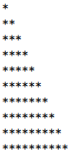

**Code:**

for i in range(1,11):

for j in range(1,i):

print('*',end='')

print( )

"""Using While loop"""

i=1

while i<11:

j=1

while j<i:

print('*',end='')

j=j+1

print( )

i=i+1

**Output:**

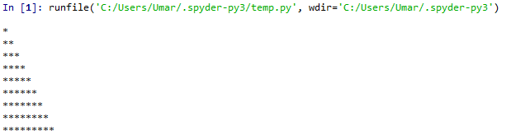

Output of task 1. Part(A) using for loop

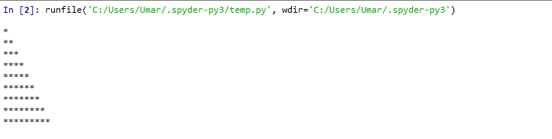

Output of task 1. Part(A) using while loop

**Part(B):**

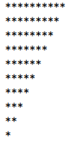

**Code:**

for r in range(0,10):

for s in range(10,r,-1):

print("*",end='')

print( )

"""Using While loop"""

r=0

while r<10:

s=10

while s>r:

print("*",end='')

s=s-1

print( )

r=r+1

**Output:**

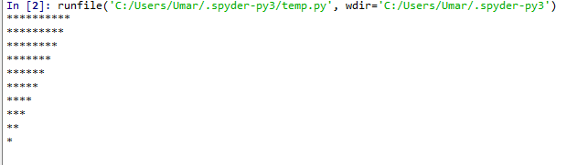

Output of task 1 Part(B) with for loop.

. 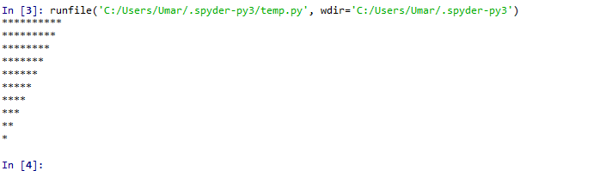

Output of task 1, Part(A) using while loop

**Part(C)**

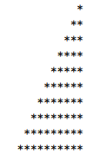

**Code:**

for r in range(1,11):

for s in range(1,s):

print("",end='')

for t in range(11,r,-1):

print("*",end='')

print ( )

**Output:**

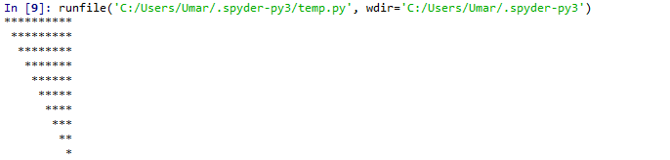

Output of task 1 Part(C) with for loop

**Part(D)**

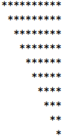

**Code:**

for r in range(11,1,-1):

for s in range(1,r):

print(" ",end='')

for t in range(r,11):

print("*",end='')

print ( )

**Output:**

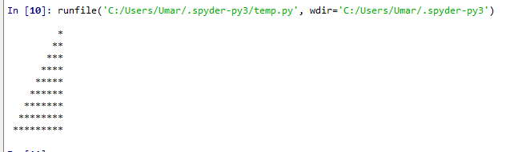

**Task 2:**

Write a program.

**9 7 5 3 1**

**7 5 3 1**

**5 3 1**

**3 1**

**1**

**Code:**

for r in range(9,0,-2):

for s in range(r,0,-2):

print(s,end=' ')

print ( )

**Output:**

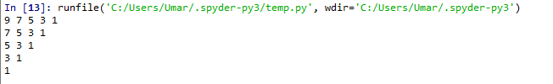

Output of task 2 with for loop

**Conclusion:**

**I**n this lab, I learnt how to print stars in different ways by using while and for loop. I also learn how to print numbers in the form of triangle by using for loop.